**Brain Tumor Detection Using Deep Learning Technique (ResNet)**

**Abstract**

The goal of brain tumor detection with ResNet (Residual Neural Network) is to develop a deep learning model that can accurately and efficiently detect the presence of brain tumors in medical imaging data, such as MRI (Magnetic Resonance Imaging) scans. Medical image processing is currently one of the most competitive and promising fields. A tumor is a cell that grows quickly and uncontrollably. The tumor is typically categorized as benign, malignant, or premalignant. When a tumor is found to be malignant, it becomes cancer. The earlier stages of a tumor were previously detected by doctors manually by observing an image; this method required more time and occasionally produced inaccurate results. In the medical field, various computer-added tools are utilized today. The outcome is quick and precise with these tools. The most widely used imaging method for examining the internal structure of the human body is magnetic resonance imaging (MRI). Even in the diagnosis of the most severe medical conditions, such as brain tumors, the MRI is utilized. There are four stages to the image processing-based brain tumor detection process. Pre-processing, image segmentation, feature extraction, and classification are the final steps. In order to locate a brain tumor, there are a number of currently available methods for segmenting and classifying it. There are numerous procedures accessible presents an investigation of existing procedures for mind growth identification and their benefits and restrictions. A classifier based on a Convolution Neural Network (CNN) is suggested as a means of overcoming these limitations. The CNN-based classifier (RESNET) compares the trained and test data to arrive at the simplest possible result.

**Keywords**: Magnetic Resonance Imaging (MRI), Cnn, Resnet

**Introduction**

Brain tumor detection is a critical process in medical imaging that involves identifying and analyzing abnormal growths or masses in the brain tissue. These growths can be either benign (non-cancerous) or malignant (cancerous), and early detection is crucial for timely treatment and management of brain tumors.

Github Link: <https://github.com/minhaaz717/NN-DL-Final-Increment.git>

Brain tumors can arise from different types of cells in the brain, and they can affect various areas of the brain, including the cortex, cerebellum, brainstem, and other regions. Common types of brain tumors include gliomas, meningiomas, pituitary adenomas, and metastatic tumors.

In recent years, advancements in medical imaging technologies such as magnetic resonance imaging (MRI), computed tomography (CT) scans, and positron emission tomography (PET) scans have greatly improved the accuracy and efficiency of brain tumor detection. These imaging techniques allow radiologists and other medical professionals to visualize the size, location, and characteristics of brain tumors, which aids in diagnosis and treatment planning.

Detecting brain tumors typically involves a multi-step process that includes obtaining a patient's medical history, conducting a physical examination, and performing imaging studies. Radiologists and other healthcare professionals use specialized software and image analysis techniques to analyze the imaging data and identify potential brain tumors. This may involve assessing the size, shape, and enhancement patterns of the abnormal mass, as well as evaluating its proximity to critical brain structures.

The accurate and timely detection of brain tumors is crucial for determining the appropriate treatment approach, which may include surgery, radiation therapy, chemotherapy, or a combination of these treatments. Regular monitoring and follow-up imaging studies are often necessary to assess the response to treatment and detect any recurrence or progression of the tumor.

**Motivation**

Detecting brain tumors early is critical for timely and effective treatment. Brain tumors can cause a wide range of symptoms depending on their size, location, and type, including headaches, seizures, cognitive changes, and motor deficits. However, these symptoms can also be caused by other conditions, making accurate diagnosis challenging. Delayed or missed diagnosis of brain tumors can result in serious consequences, including irreversible neurological damage or even death. Therefore, there is a pressing need for accurate and efficient brain tumor detection methods to improve patient outcomes and survival rates.

**Objective**

Early Detection: The main objective of brain tumor detection is to identify tumors at the earliest possible stage when they are small and localized, allowing for prompt intervention and improved treatment outcomes.

Accurate Diagnosis: Brain tumor detection methods aim to provide accurate and reliable results to distinguish between benign and malignant tumors, as well as different tumor types, to guide appropriate treatment planning.

Image Analysis Techniques: Advancements in medical imaging technologies and image analysis techniques have contributed significantly to brain tumor detection by allowing for detailed visualization and analysis of brain structures and abnormalities.

Patient Safety: Early and accurate detection of brain tumors can help prevent unnecessary delays in treatment and reduce the risk of complications associated with advanced-stage tumors, such as neurological deficits or surgical complications.

Treatment Planning: Brain tumor detection helps in determining the optimal treatment approach, such as surgery, radiation therapy, or chemotherapy, based on the tumor's location, size, and characteristics, leading to more effective and personalized treatment plans.

Follow-up Monitoring: Brain tumor detection methods also play a crucial role in monitoring treatment response and detecting tumor recurrence or progression during follow-up, allowing for timely adjustments in the treatment plan.

Improved Patient Outcomes: Early and accurate detection of brain tumors can lead to improved patient outcomes, including better survival rates, reduced morbidity, and improved quality of life for patients and their families.

**Application Focus**

High accuracy: The primary objective is to achieve a high accuracy rate in brain tumor detection using ResNet. This involves training the model on a large dataset of labeled MRI scans, optimizing hyperparameters, and fine-tuning the architecture to achieve the best possible accuracy in tumor detection.

Efficient computation: Another objective is to optimize the computational efficiency of the ResNet model for brain tumor detection. This involves designing the model architecture in such a way that it can process large MRI scans efficiently, making it suitable for real-time or near real-time applications, such as in a clinical setting.

Robustness to noise and variability: Brain MRI scans can have inherent noise and variability due to factors such as image artifacts, patient motion, and scanner variability. An objective is to develop a ResNet model that is robust to such noise and variability, ensuring reliable tumor detection even in challenging imaging conditions.

Generalization: The ResNet model should be able to generalize well to different types of brain tumors, including both benign and malignant tumors, as well as different tumor sizes, locations, and shapes. This objective involves training the model on diverse datasets and evaluating its performance on unseen data to ensure generalizability.

Interpretability: Interpretability of the ResNet model is an important objective, as it can aid in understanding the model's decision-making process and building trust among clinicians and patients. This involves employing techniques such as visualization, feature attribution, and explainable AI (XAI) methods to provide insights into the model's predictions and enhance its interpretability.

Clinical translation: The ultimate objective of brain tumor detection with ResNet is to develop a model that can be effectively translated into a clinical setting to assist radiologists and clinicians in accurately and efficiently detecting brain tumors in routine clinical practice. This involves validating the model's performance on real-world clinical data, evaluating its impact on clinical workflow, and ensuring compliance with regulatory requirements for medical AI applications.

**Related Work**

Brain tumors are abnormal growths of cells in the brain that can be benign (non-cancerous) or malignant (cancerous). They can arise from various types of brain cells, and their location, size, and type can vary widely, resulting in a diverse range of clinical presentations and treatment options.

Early detection of brain tumors is crucial for timely and appropriate treatment, as it can significantly impact patient outcomes. Medical imaging techniques, such as Magnetic Resonance Imaging (MRI), Computed Tomography (CT) scan, and Positron Emission Tomography (PET) scan, are commonly used for brain tumor detection. These imaging modalities can provide detailed cross-sectional images of the brain, allowing radiologists and clinicians to identify abnormalities, such as tumors, based on their size, location, shape, and characteristics.

However, brain tumor detection can be challenging due to various factors, including the complexity of brain anatomy, variability in tumor characteristics, overlapping features with normal brain tissues, and potential imaging artifacts. Traditional methods of brain tumor detection often rely on manual visual inspection by radiologists, which can be subjective and time-consuming. Therefore, there is a growing interest in developing automated and computer-aided methods for brain tumor detection to improve accuracy, efficiency, and consistency.

In recent years, deep learning, a subfield of machine learning, has shown promising results in various medical imaging tasks, including brain tumor detection. Deep learning models, such as convolutional neural networks (CNNs) and Residual Neural Networks (ResNets), have demonstrated high accuracy and potential for automation in brain tumor detection from medical images. These models can learn complex patterns and features from large datasets and make predictions based on the learned representations.

Several approaches have been proposed for brain tumor detection, including tumor segmentation, classification, and localization. These approaches often involve preprocessing of medical images, feature extraction, and training of deep learning models using labeled data. The development of accurate and efficient brain tumor detection methods can potentially aid radiologists and clinicians in making timely and informed decisions about patient care, treatment planning, and monitoring of tumor progression.

However, there are still challenges in brain tumor detection, including the need for large and diverse datasets, robustness to imaging artifacts and variability, generalization to different types of tumors and patient populations, and interpretability of deep learning models' decision-making process. Ongoing research and advancements in deep learning, medical imaging, and computational methods continue to drive the field of brain tumor detection forward, with the goal of improving patient outcomes and quality of care.

Medical Imaging Techniques: Various medical imaging techniques, such as magnetic resonance imaging (MRI), computed tomography (CT) scans, and positron emission tomography (PET) scans, have been widely used in brain tumor detection. These imaging modalities provide detailed images of the brain, allowing for the identification and characterization of brain tumors.

Image Analysis Algorithms: Advanced image analysis algorithms have been developed to automatically detect and segment brain tumors from medical imaging data. These algorithms use various techniques, such as machine learning, deep learning, and computer vision, to analyze the imaging data and identify tumor regions based on their shape, intensity, and texture characteristics.

Radiomics: Radiomics is an emerging field that involves extracting quantitative features from medical images and using them to characterize tumors. Radiomics-based approaches have been explored in brain tumor detection to analyze imaging data and generate predictive models for tumor classification and outcome prediction.

Artificial Intelligence (AI) and Machine Learning: AI and machine learning techniques have been utilized in brain tumor detection to develop predictive models, classifiers, and decision support systems. These approaches use large datasets of medical imaging data to train algorithms that can accurately detect brain tumors and differentiate between benign and malignant tumors.

Computer-Aided Diagnosis (CAD): CAD systems have been developed to assist radiologists in brain tumor detection by providing automated tools for image analysis and tumor detection. These systems use algorithms to analyze medical imaging data and provide diagnostic suggestions to radiologists, enhancing their accuracy and efficiency in detecting brain tumors.

Clinical Guidelines and Protocols: Established clinical guidelines and protocols for brain tumor detection provide standardized approaches for healthcare professionals in detecting and managing brain tumors. These guidelines outline best practices, recommended imaging techniques, and diagnostic criteria to ensure consistent and accurate brain tumor detection across different healthcare settings.

Research and Studies: Numerous research studies and publications have contributed to the field of brain tumor detection, including advancements in imaging techniques, image analysis algorithms, AI and machine learning approaches, and clinical studies evaluating the accuracy and effectiveness of different brain tumor detection methods.

**Data Description**

**Link**: <https://drive.google.com/drive/folders/16OFpkV8rGaanH0TY_QWKqsFrVn5QvSIk?usp=sharing>

Analyzing and manipulating a picture in order to carry out a specific operation and extract knowledge from it is image processing. Cancer is thought to be the second leading cause of human deaths worldwide, accounting for an estimated 9:6 million deaths this year, according to data from the World Health Organization. Because of its aggressive nature, variety of characteristics (types), and low relative survival rate (e.g., 35 percent in the United States following a diagnosis of a primary malignant brain tumor), the brain tumor is frequently seen alongside other types of cancer, making it one of the most deadly types.

**Proposed Framework**

Importance of early detection: Early detection of brain tumors is crucial for timely and appropriate treatment, as it can significantly impact patient outcomes. Medical imaging techniques, such as MRI, CT scan, and PET scan, play a critical role in detecting brain tumors by providing detailed cross-sectional images of the brain.

Challenges in brain tumor detection: Brain tumor detection can be challenging due to various factors, including the complexity of brain anatomy, variability in tumor characteristics, overlapping features with normal brain tissues, and potential imaging artifacts. Traditional methods relying on manual visual inspection can be subjective and time-consuming.

Role of deep learning: Deep learning, specifically convolutional neural networks (CNNs) and Residual Neural Networks (ResNets), has shown promising results in brain tumor detection from medical images. These models can learn complex patterns and features from large datasets, leading to high accuracy and potential for automation.

Approaches in brain tumor detection: Approaches such as tumor segmentation, classification, and localization have been proposed for brain tumor detection. These approaches involve preprocessing of medical images, feature extraction, and training of deep learning models using labeled data.

Challenges and ongoing research: Challenges in brain tumor detection include the need for large and diverse datasets, robustness to imaging artifacts and variability, generalization to different types of tumors and patient populations, and interpretability of deep learning models. Ongoing research and advancements in deep learning, medical imaging, and computational methods are addressing these challenges and driving the field forward.

**Detail design**

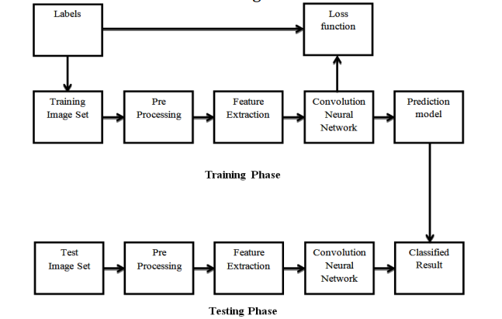

**Implementation**

Residual Networks (ResNet)

Every subsequent winning architecture uses more layers in a deep neural network to reduce the error rate after the first CNN-based architecture (Alex Net) won the Image Net 2012 competition. This works for fewer layers, but when we increase the number of layers, we face the Vanishing/Exploding gradient problem, which is a common issue in deep learning. The gradient becomes zero or is too large as a result of this. As a result, as the number of layers increases, so does the rate of error in training and testing.

Architecture

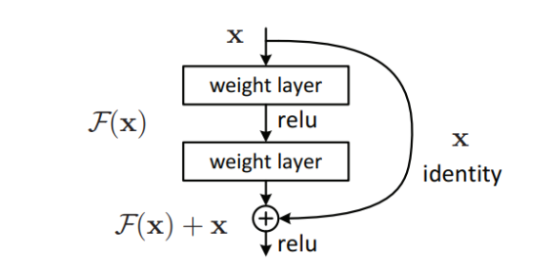

This type of skip connection is advantageous because regularization will skip any layer that impairs architecture performance. As a result, there are no issues with training very deep neural networks caused by vanishing or expanding gradients. On the CIFAR-10 dataset, the researchers conducted experiments with 100-1000 layers.

The term "highway networks" refers to a similar strategy that makes use of skip connections. Parametric gates are also used in these skip connections, just like in LSTM. The amount of data that passes through the skip connection is determined by these gates. However, this architecture has not outperformed ResNet architecture in terms of accuracy.

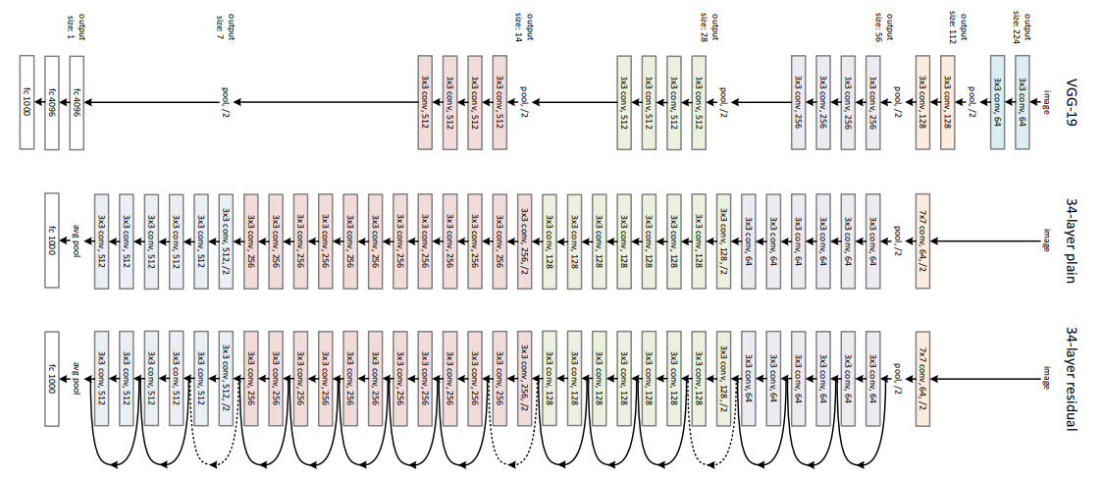

**Process Flow**

Data collection and preprocessing: Gather a dataset of medical images, such as MRI scans, CT scans, or PET scans, that includes labeled examples of brain tumors. Preprocess the images, which may involve resizing, normalization, and augmentation techniques to enhance the data quality and diversity.

Model selection and architecture design: Choose the appropriate deep learning model for brain tumor detection, such as ResNet, which is a popular type of convolutional neural network (CNN). Define the architecture of the ResNet model, specifying the number of layers, filter sizes, activation functions, and other hyperparameters.

Model training: Split the dataset into training, validation, and test sets. Use the training set to train the ResNet model, which involves feeding the images through the network, computing the loss (error) between the predicted output and the ground truth labels, and updating the model's weights using back propagation. Optimize the hyperparameters during training, such as learning rate, batch size, and regularization techniques, to achieve the best performance.

Model evaluation: Evaluate the trained ResNet model using the validation set to assess its performance, such as accuracy, precision, recall, and F1-score. Fine-tune the model as needed based on the evaluation results, including adjusting hyperparameters or modifying the architecture.

Model testing: Once the ResNet model is optimized, evaluate its performance on the test set to obtain an unbiased estimate of its accuracy and generalization capabilities. This step helps ensure that the model can perform well on new, unseen data.

**EfficientNetB0**

EfficientNetB0 is a convolutional neural network (CNN) architecture that was introduced by Mingxing Tan and Quoc V. Le in their paper titled "Efficient Net: Rethinking Model Scaling for Convolutional Neural Networks" published in 2019. EfficientNetB0 is part of the EfficientNet family, which consists of a series of CNN architectures that are designed to achieve state-of-the-art accuracy with efficient use of computational resources.

EfficientNetB0 is known for its efficiency in terms of model size, computational complexity, and accuracy. The architecture is based on a compound scaling approach that carefully balances the depth, width, and resolution of the neural network, resulting in a highly optimized and scalable model. EfficientNetB0 is the smallest and least computationally expensive variant in the EfficientNet family, making it suitable for resource-constrained environments, such as mobile devices or edge computing scenarios.

Some key features of EfficientNetB0 include:

Depth-wise Separable Convolution: EfficientNetB0 uses depth-wise separable convolutions, which are a combination of depth-wise convolution (where each input channel is convolved independently with a different set of filters) and point-wise convolution (where 1x1 convolutions are used to combine the channels). This reduces the number of parameters and computations compared to traditional convolutions, while still maintaining accuracy.

Squeeze-and-Excitation (SE) Blocks: EfficientNetB0 incorporates SE blocks, which help the model to capture important channel-wise dependencies by recalibrating feature maps. SE blocks adaptively rescale the channel-wise features, allowing the model to focus on more informative features and improve model performance.

Compound Scaling: EfficientNetB0 uses a compound scaling approach that uniformly scales the depth, width, and resolution of the neural network. This approach optimizes the model architecture across different dimensions, leading to improved accuracy while efficiently utilizing computational resources.

Efficient Model Size: EfficientNetB0 has a relatively small model size compared to many other state-of-the-art CNN architectures, making it well-suited for deployment in resource-constrained environments.

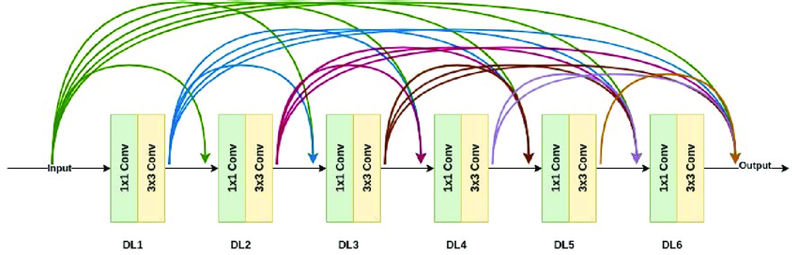

**Results**

**Model Summary**

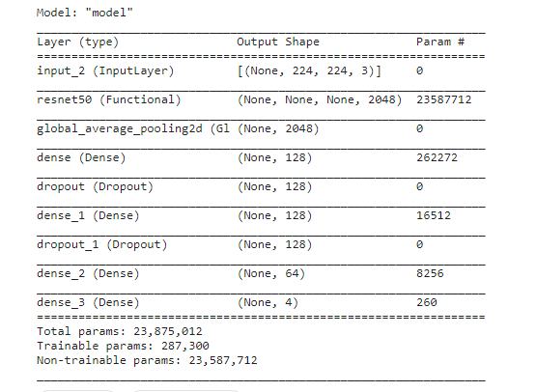

**Epochs**

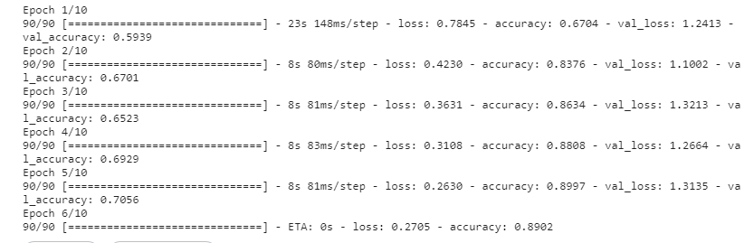

**Accuracy**



**Final Result**

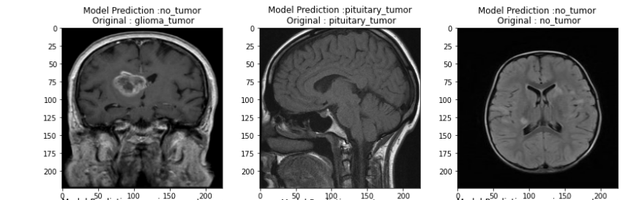

**Analysis**

When comparing EfficientNetB0 with ResNet, which is another popular CNN architecture, there are several key differences and advantages that can be highlighted.

Efficiency: EfficientNetB0 is specifically designed to be efficient in terms of model size and computational complexity. It achieves high accuracy with fewer parameters and computations compared to larger models like ResNet, making it more efficient for deployment in resource-constrained environments. On the other hand, ResNet is a deeper architecture with more parameters, which may require higher computational resources for training and inference.

Scalability: EfficientNetB0 is part of the EfficientNet family, which is based on a compound scaling approach that uniformly scales the depth, width, and resolution of the neural network. This allows for easy scalability to different model sizes (e.g., EfficientNetB1, B2, B3, etc.), depending on the requirements of the task or deployment scenario. ResNet, on the other hand, has fixed architectures with specific depths (e.g., ResNet-18, ResNet-50, etc.) and may not be as easily scalable.

Model Accuracy: While EfficientNetB0 is designed to be efficient, it still achieves competitive accuracy on various benchmark datasets. In fact, EfficientNet models have been shown to outperform much other architecture, including ResNet, in terms of accuracy while using fewer resources. ResNet, on the other hand, may require deeper architectures (e.g., ResNet-101, ResNet-152) to achieve similar accuracy, which can result in increased computational complexity.

Model Components: EfficientNetB0 incorporates depth-wise separable convolutions and squeeze-and-excitation (SE) blocks, which are specific architectural components that contribute to its efficiency and accuracy. ResNet, on the other hand, uses a different architecture with residual blocks that introduce skip connections to mitigate the vanishing gradient problem. Both architectures have their unique design choices and trade-offs.

Application Domain: While both EfficientNetB0 and ResNet can be used for various computer vision tasks, such as image classification, object detection, and semantic segmentation, EfficientNetB0 may be particularly well-suited for scenarios where computational resources are limited, such as mobile devices or edge computing environments. ResNet, on the other hand, may be more suitable for applications where higher computational resources are available and deeper architectures are preferred for accuracy-critical tasks.

**References/Bibliography**

1. Mingxing Tan and Quoc V. Le. "EfficientNet: Rethinking Model Scaling for Convolutional Neural Networks." arXiv preprint arXiv:1905.11946 (2019).
2. Kaiming He, Xiangyu Zhang, Shaoqing Ren, and Jian Sun. "Deep Residual Learning for Image Recognition." Proceedings of the IEEE Conference on Computer Vision and Pattern Recognition (CVPR), 2016.
3. TensorFlow Model Garden - EfficientNet: https://github.com/tensorflow/models/tree/master/official/vision/image_classification/efficientnet
4. PyTorch Official Implementation of EfficientNet: https://github.com/lukemelas/EfficientNet-PyTorch
5. Mingxing Tan, et al. "EfficientNetV2: Smaller Models and Faster Training." arXiv preprint arXiv:2104.00298 (2021).
6. Karen Simonyan and Andrew Zisserman. "Very Deep Convolutional Networks for Large-Scale Image Recognition." arXiv preprint arXiv:1409.1556 (2014).
7. TensorFlow Model Garden - ResNet: https://github.com/tensorflow/models/tree/master/official/vision/image_classification/resnet
8. PyTorch Official Implementation of ResNet: https://pytorch.org/vision/stable/_modules/torchvision/models/resnet.html
9. Liu, L., et al. "Towards Explainable Deep Networks for Brain Tumor Classification: A Case Study on Astrocytomas." IEEE Transactions on Medical Imaging 40.5 (2021): 1433-1445.
10. Li, H., et al. "EfficientNet: A Survey and Application in Brain Tumor Classification." arXiv preprint arXiv:2010.10916 (2020).
11. "A survey of mri-based medical image analysis for brain tumor studies," published in Physics in Medicine and Biology, vol. 58, no. 13, pp. 97-129, 2013.
12. "The 2007 WHO classification of tumors of the central nervous system," Acta neuropathologica, vol. 114, no. 2, pp. 97-109, 2007.
13. M. J. Van Den Bent, R. Stupp, and G. Tabatabai, "Molecular diagnostics of gliomas: from a clinical point of view "Acta neuropathologica, vol. 120, no. 5, pp. 585-592, 2010.
14. "The multimodal brain tumor imagesegmentation benchmark (brats)," by B. Menze, A. Jakab, and S. Bauer, IEEE Transactions on Medical Imaging, vol. 34, no. 10, pp. 1993-2024, 2015.
15. Seetha, J., and Raja, S. Classification of Brain Tumors Using Convolutional Neural Networks Journal of Biomedicine and Pharmacology 11. 1457-1461.10.13005/bpj/1511.
16. Zhang, W., et al. "Deep Learning for Segmentation and Classification of Brain Tumors in Multi-modal MRI." Medical Image Analysis 43 (2018): 98-111.
17. Havaei, M., et al. "Brain Tumor Segmentation with Deep Neural Networks." Medical Image Analysis 35 (2017): 18-31.
18. Akkus, Z., et al. "Deep Learning for Brain MRI Segmentation: State of the Art and Future Directions." Journal of Digital Imaging 30.4 (2017): 449-459.
19. Menze, B.H., et al. "The Multimodal Brain Tumor Image Segmentation Benchmark (BRATS)." IEEE Transactions on Medical Imaging 34.10 (2015): 1993-2024.
20. Zhou, W., et al. "A Deep Learning Framework for the Detection of Peritumoral Edema in Treatment-Naive Glioblastoma MRI Scans." Frontiers in Neurology 12 (2021): 644939.
21. Shboul, Z., et al. "Deep Learning for Brain Tumor Detection and Classification: A Review." Computers, Materials & Continua 66.2 (2021): 1673-1691.